Your Right to Know / Jacob Resneck

Limit privacy protections for police

Law enforcement officers in Winnebago County shot three people in 2023, one fatally. And while we know the names of the people shot, the identities of those who pulled the trigger remain secret.

The fatal shooting, on Aug. 2, was of an armed 37-year-old man at a Neenah gas station by an Outagamie County sheriff’s deputy and an Appleton police officer, both members of the Lake Winnebago Area Metropolitan Enforcement Group, a narcotics enforcement unit. The two nonfatal shootings, on March 17 and June 29, involved Oshkosh police officers.

Even after investigations have cleared all three officers of wrongdoing, officials have withheld their identities, citing different rationales.

In the fatal shooting, Sheboygan County DA Joel Urmanski said the Appleton police department requested its officer’s name be withheld because “they work in an undercover capacity.” And the Outagamie County Sheriff’s Department continues to withhold its deputy’s name due to “credible threats” to safety.

Authorities in northwestern Wisconsin have also cited “a threat directed at officers” who shot and killed a knife-wielding suspect on Oct. 8 to withhold release of their names. The state Department of Justice led the investigation of the shooting by two Rice Lake police officers but more than a month after completing its probe has still not released the investigatory file on its website, a deviation from usual practice.

In the nonfatal shootings, in which the suspects face felony charges, Winnebago County District Attorney Eric Sparr has cited Marsy’s Law, a state constitution amendment passed in Wisconsin in 2020, to enhance the rights of crime victims. Sparr said in an interview that the officers’ names are being withheld “just the same way we wouldn’t release the names of victims in other cases.”

Law enforcement agencies in Florida and Ohio have similarly cited those states’ version of Marsy’s Law in refusing to release the names of officers involved in shootings. In late November, Florida’s conservative-leaning Supreme Court rejected anonymity for police officers who shot and killed suspects. But the practice remains untested in Wisconsin courts.

Tom Kamenick, an attorney and founder of the Wisconsin Transparency Project, doesn’t buy that undercover officers can’t be named, especially given that they don’t use their real names in the field. “I’m very wary of government agencies claiming that the identities of government employees who killed people need to be kept secret,” he said.

Meanwhile, the Oshkosh Police Department took months to release bodycam footage from both non-fatal encounters. In one case, the footage was redacted to obscure the image of the armed man shot — which even the district attorney said went too far.

“Since that was ruled a justified shooting, he would not be the victim of a crime,” Sparr said.

Oshkosh police refused to explain their reasoning for the edits. But its records division released a less obscured redacted version three weeks later.

Now, if Republican lawmakers have their way, it could soon be prohibitively expensive for news outlets and members of the public to obtain such footage. A bill backed by law enforcement groups and recently introduced in the state Senate would allow police agencies to charge for the time it spent editing and redacting bodycam footage before it’s released to the public.

The Wisconsin Department of Justice’s guidance on Marsy’s Law puts the burden on local authorities to balance between privacy and transparency as required by law. Kamenick thinks that’s not enough. “It really would have helped if the attorney general's office would have put out clearer guidance,” he said.

In lieu of this, it is up to the public and the press to demand minimal standards of accountability and transparency for police officers who shoot — and even kill — people in the line of duty.

Your Right to Know is a monthly column distributed by the Wisconsin Freedom of Information Council (wisfoic.org), a nonprofit, nonpartisan group dedicated to open government. Jacob Resneck is an investigative reporter with Wisconsin Watch.

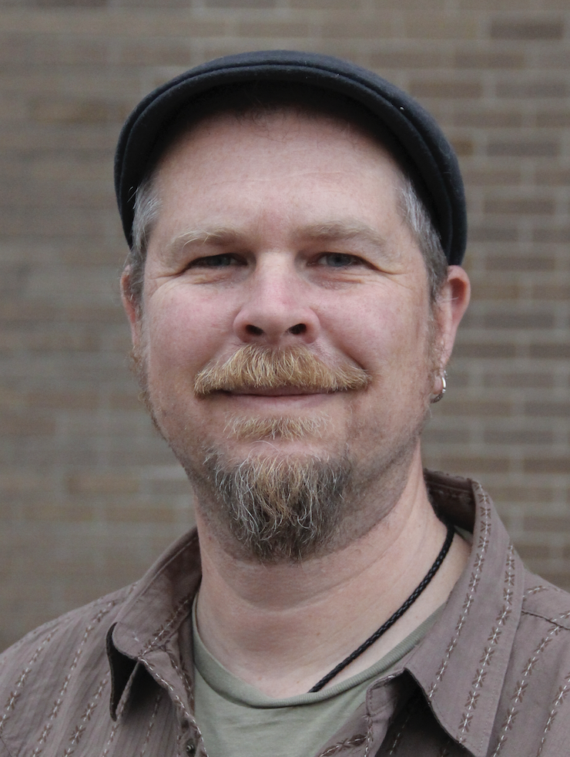
Jacob Resneck, provided photo

