Your Right to Know / Larry Gallup

Protect the rights of student journalists

About a year ago, Simon Mehring came home from a high school journalism conference with an idea.

Mehring, now a junior at Stoughton High School, had learned about an Illinois law that protects student media from censorship. He also found out that Wisconsin doesn’t have such a law.

So, armed with model legislation from the Student Press Law Center, he raised the issue with state legislators, in conversations that lasted through the school year and into the summer.

Mehring, in an interview, said he spoke several times with Rep. Dave Murphy (R-Greenville), who chairs the Assembly Committee on Colleges and Universities. This fall, Mehring was at school and “all of a sudden, I got the news that they were going to introduce the bill.”

The legislation, AB 551, was patterned off the model legislation. It’s co-authored by Sen. Rachael Cabral-Guevara (R-Appleton) and Rep. Tom Michalski (R-Elm Grove), with cosponsors from both parties. It was introduced on Oct. 23 and had a hearing in Murphy’s committee on Oct. 26. It passed a committee on Nov. 2 and five days later was voted on by the full Assembly, where it passed unanimously.

“The biggest surprise is how fast it went,” says Mehring, who, along with testifying at the Assembly hearing, submitted letters from other Wisconsin student journalists who have experienced censorship.

The bill as passed would do several things:

- Establish that public-school journalists in grades 6-12 and student journalists at a UW System university or a technical college have “the right to exercise freedom of speech and of the press in school-sponsored media.”
- Let student journalists determine “the news, opinion, feature, and advertising content of school-sponsored media” and prohibit school officials from “exercising prior restraint of materials.”
- Preclude student journalists and their advisors from being disciplined for “for acting in accordance with the bill” and give the ability to enforce their rights in the courts.
- Require school districts, the UW System and technical college boards to “adopt a policy related to student journalists exercising their freedom of speech and the press in school-sponsored media,” including an appeal process for students.

The Student Law Press Center says 17 states have passed similar bills intended to offset a 1988 U.S. Supreme Court decision that muddied the issue of censorship of student media.

Some of the support for the Wisconsin bill comes from Republican legislators concerned about protecting the free speech rights of conservative students on UW campuses. But the unanimous
vote shows that the ideals it seeks to protect have deep bipartisan support.

The bill did draw criticism from Howard Schweber, a UW-Madison professor of American politics and political theory, who told the Badger Herald newspaper it might be a “disastrously bad idea” to give middle-school and high-school students the same press freedom as college students.

But Matthew Smith, a Fond du Lac journalism teacher, student journalism advisor and the president of the Wisconsin Journalism Education Association, said at the Oct. 26 hearing that he knows from experience the legislation will work at the high-school level, having seen how students “follow the standards we talk about in class” — that is, to behave responsibly and “focus on truth.”

The bill is now with a Senate committee and would need committee and full Senate approval before going to Gov. Tony Evers.

Mehring is hopeful about its chances — and stresses its importance. “Even though this bill is a niche issue,” he says, ‘it affects a lot of people.”

Your Right to Know is a monthly column distributed by the Wisconsin Freedom of Information Council (wisfoic.org), a nonpartisan group dedicated to open government. Council member Larry Gallup is the audience growth editor for USA TODAY NETWORK-Wisconsin. He can be reached at lgallup@gannett.com.

Larry Gallup, provided photo

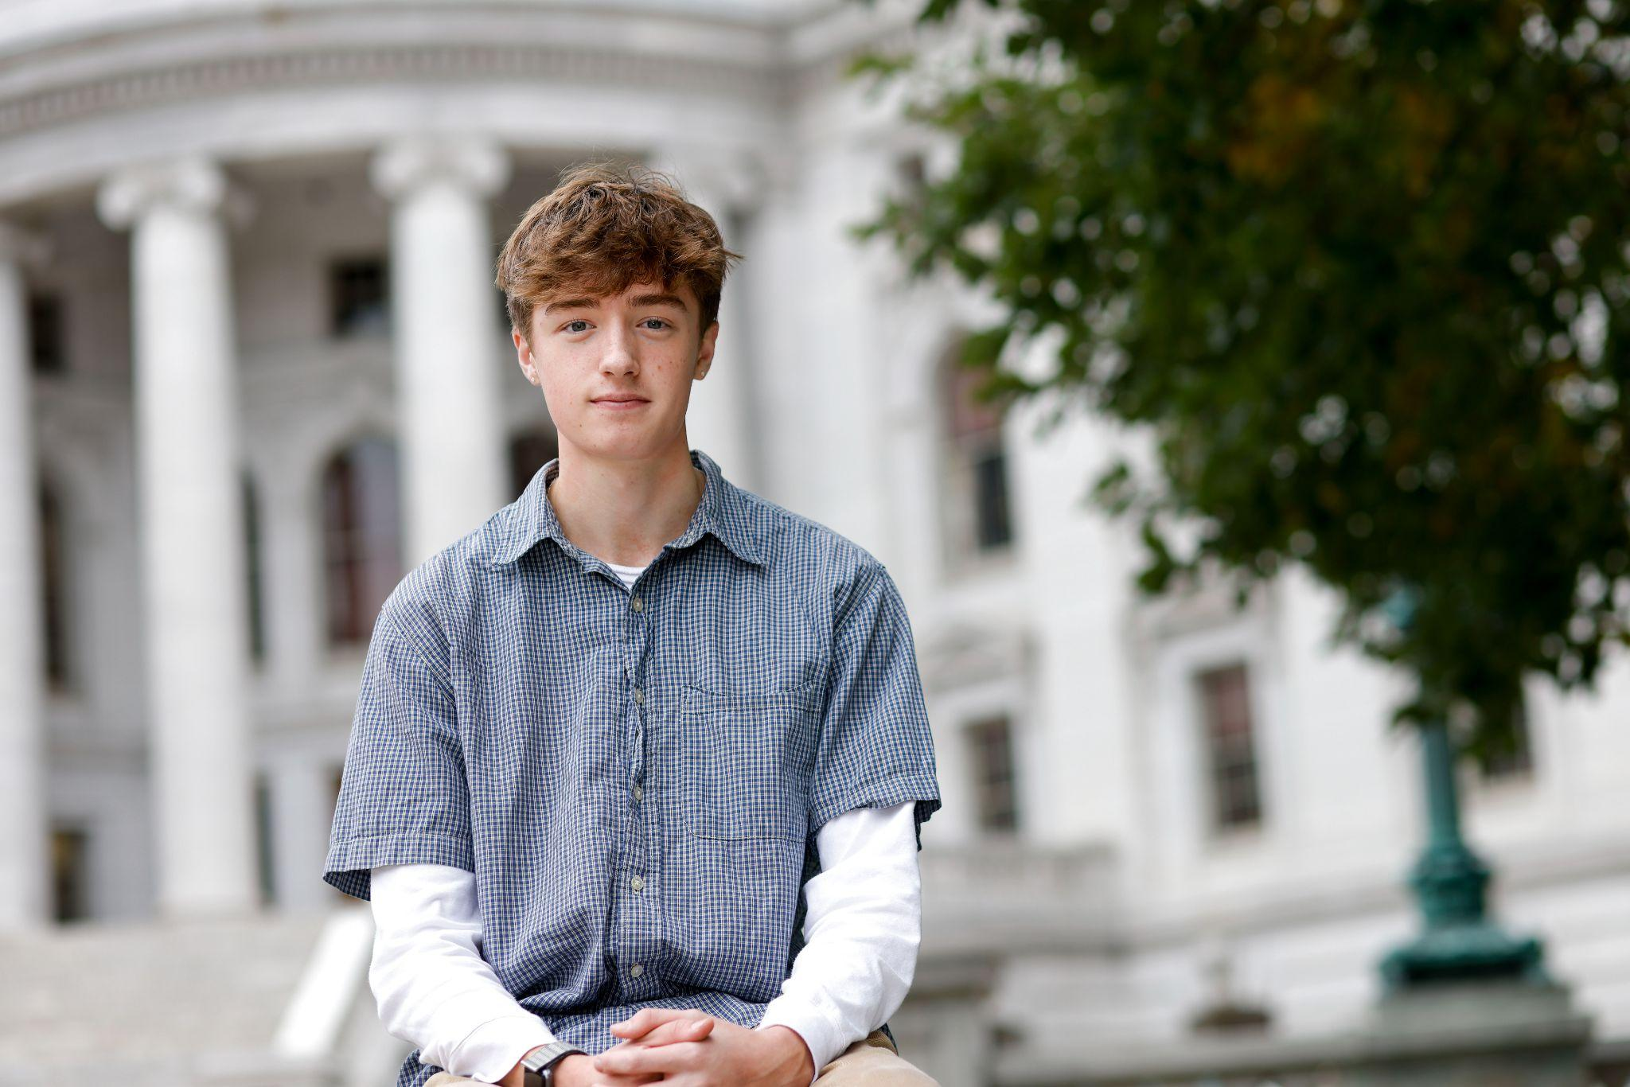
Photo of Simon Mehring by Ruthie Hauge, courtesy of the Capital Times

